**DAILY ONLINE ACTIVITIES SUMMARY**

|  |  |  |  |  |  |  |  |  |
| --- | --- | --- | --- | --- | --- | --- | --- | --- |
| **Date:** | **11-06-2020** | | | | | **Name:** | **Shiza Amreen.J** | |
| **Sem & Sec** | **4th sem B sec** | | | | | **USN:** | **4AL18CS078** | |
| **Online Test Summary** | | | | | | | | |
| **Subject** | | **--** | | | | | | |
| **Max. Marks** | | **--** | | **Score** | | | **--** | |
| **Certification Course Summary** | | | | | | | | |
| **Course** | **Introduction to Cyber Security** | | | | | | | |
| **Certificate Provider** | | | **GreatLearning** | | **Duration** | | | **5.5 Hours** |
| **Coding Challenges** | | | | | | | | |
| **Problem Statement: Write a Java program to Segregate Even and Odd numbers.** | | | | | | | | |
| **Status: Completed** | | | | | | | | |
| **Uploaded the report in Github** | | | | | **yes** | | | |
| **If yes Repository name** | | | | | **Lockdown_Coding** | | | |
| **Uploaded the report in slack** | | | | | **yes** | | | |

Certification Course Details:

Today I have attended the Online Quiz, “Technical Quiz by CSE Department” which was held by ‘Netaji Institute of Engineering and Technology’, Telangana.

<https://docs.google.com/forms/d/e/1FAIpQLSfa6nY8bVPRDPHkJkeh_-zSf2PZe7xZrLQtqhsOYat1Qtt-Lw/viewform>

I have attended the quiz and successfully got the certificate.



|  |
| --- |
|  |
|

Certificate ID: UF8XI8-CE000166

<https://mail.google.com/mail/u/0?ui=2&ik=75e7b573e1&attid=0.1&permmsgid=msg-a:r4199400568575769484&th=172a3dff4da9ffd0&view=att&disp=inline&realattid=f_kbawj9f80>

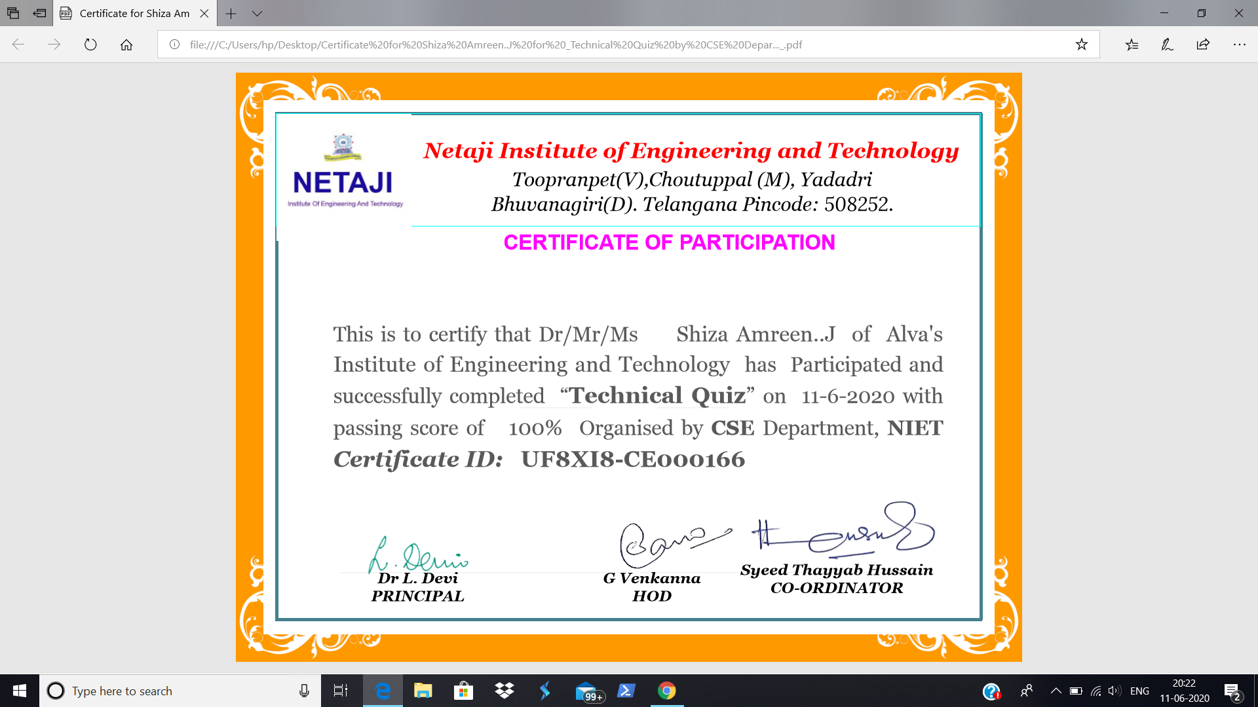

Coding Challenges Details:

|  |
| --- |
| **Problem Statement: Write a Java program to Segregate Even and Odd numbers.** |

**I have written the code for given problem statement and uploaded it in my github repository, Lockdown_Coding.**

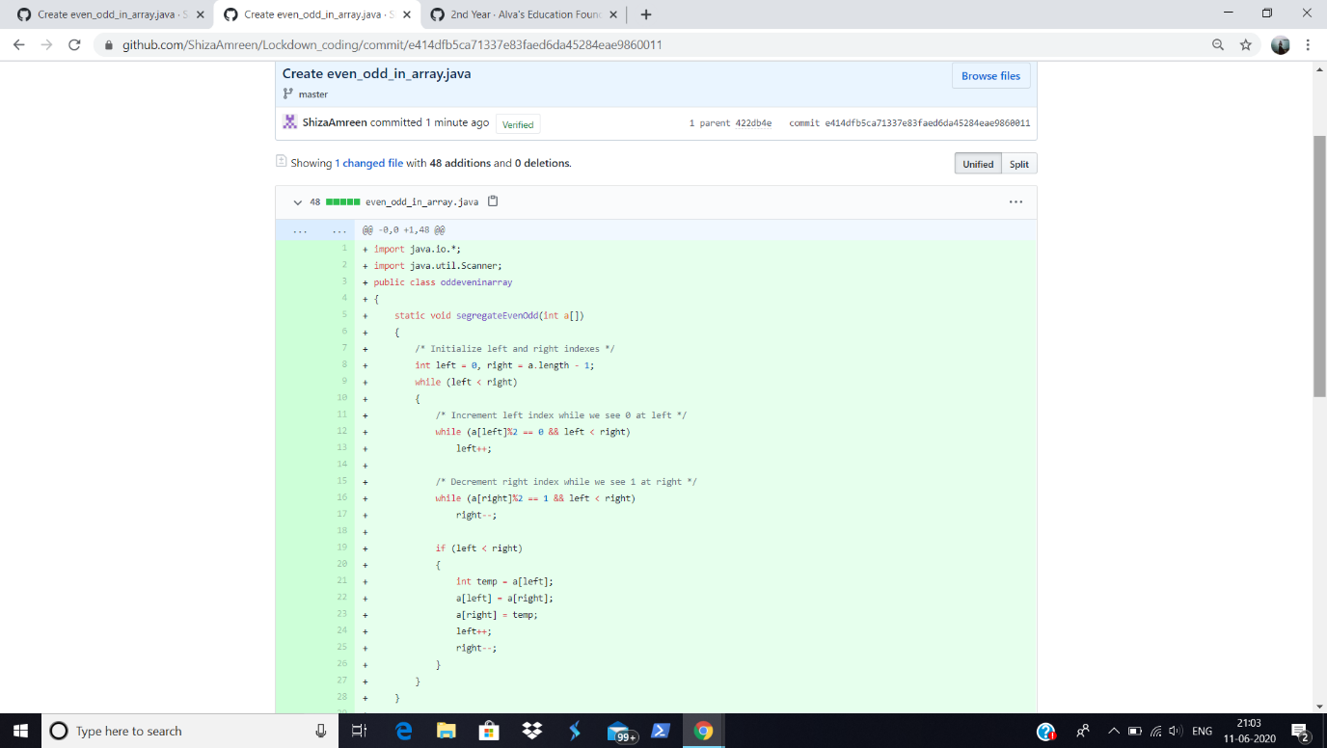

<https://github.com/ShizaAmreen/Lockdown_coding/commit/e414dfb5ca71337e83faed6da45284eae9860011>